Section A – Description of the Educational Design Project
The Christian Education Committee needed to review the Child Protection Policy (CPP) that has been in place for ten years. Significant revision was required to integrate new insurance requirements into the existing document. This educational event consisted of facilitating the process of review and revision with the additional goal of creating foundational statements and a plan for teacher training.
I chose to use an educational theory described by Jack L. Seymour, Margaret Ann Crain, and Joseph V. Crockett in their book Educating Christians: The Intersection of Meaning, Learning, and Vocation because of the mutual and open search for meaning it suggests. I found this resource specifically had an adaptation for the function of leadership, and this function was a circular approach utilizing a particularly Reformed idea that how we are called to live with wholeness and justice in the world always needs to be reevaluated. Thus the method I used to lead the committee to create a new CPP and supportive training materials was based on 1) an exploration of our current circumstances utilizing the participants’ knowledge of the various age groups, 2) a consideration of the realities of child abuse in light of a sophisticated look at some biblical foundations of our faith, and 3) a discernment of how we can live out our call to protect children in a particularly Reformed theological way.
The committee consisted of members with a variety of ages, vocational backgrounds, experiences teaching children of all age groups, and a sophisticated knowledge of education and religious education. Because the participants have knowledge of human and faith development and extensive experience with children of various age groups, I chose teaching strategies that had members teaching each other about the age groups of which they have the most understanding. My role as the teacher was to provide resources, in this case information that names and categorizes stages of human and faith development, and the role of the participants was to teach each other from their particular area of expertise or experience and to assume the role of learner to gain insight from others’ expertise.
Because of the group’s academic sophistication and knowledge of research and capability for biblical interpretation I chose teaching strategies that had members doing their own exegetical work for the bible study. For example, one man is heading off to seminary this year, another man has plans to attend seminary in the future, one woman is a college professor teaching research methods to education majors, one man is a microbiology scientist in the health care industry, and one woman trains people in the health care industry to use sophisticated products. Others have financial and business skills that involve research experience. In a Socratic way of honoring the question as a catalyst for discussion, the method I chose was to have the participant’s own questions drive the research. My role as teacher was to choose the foundational text, Psalm 8, anticipate what questions might be posed, and prepare resources to have quick access to potential answers, but to also provide for additional research as needed. The role of the participants was to work together to research, achieve deeper understanding, to interpret, and construct meaning that might be applicable to the next step of our process.
Because most of the participants were familiar with theological concepts and terminology I chose teaching strategies that had members going deeper into Reformed theology than might be expected. In the role of teacher I had to provide more information, but did so in the form of a reading assignment and some lecture components but only in order to provide a catalyst for discussion and those sparingly peppered in amongst the discussion elements.
Overall the teaching strategies employed were heavily student research oriented with group development of end-products that fed into the next phases of the project. This educational design was intended to motivate and inspire the members of the CE Committee to achieve the end goal – which might otherwise have been a boring task to complete over the summer! Discovering and articulating the biblical and theological underpinnings of our project was a foundation upon which to build a policy that would motivate and inspire those who must abide by it and a congregation that must commit to support it.

Section B – Lesson Plan
Outline of the Process to Review and Update Child Protection Policy (CPP)
EXPLORE our experiences and traditions related to educating and protecting children of various ages in our faith community.
- Preparation – review stages of development, current CPP, and develop a survey
- Immersion Experience – observe various age groups in educational environments
- Reflection – indentify issues to address
CONSIDER the foundations and meaning of what we value and seek to solve with our project so that we may be guided by clearly articulated beliefs.
- Preparation – Bible Study
- Research - realities of child abuse
- Reflection –create a statement of value and intent
DISCERN the actions needed in order to live out this commitment to protect children and our community of faith.
- Preparation – Examine Reformed thoughts on leadership in community and Providence
- Edit CPP – address issues and discern what we are called to do
- Reflection – create a plan to live out our faith commitments to protect children

Lesson Plan
The leader will facilitate the process of creating a new Child Protection Policy (CPP) and supportive training materials that articulate the Christian Education Committee’s vision for preventing child abuse based on 1) an exploration of our current circumstances at various age groups, 2) a consideration of the realities of child abuse in light of our faith, and 3) a discernment of how we can live out our call to protect children.

(1) EXPLORE our experiences and traditions related to educating and protecting children of various ages in our faith community. Understanding the developmental needs of children and how our current CPP is enacted in the various learning environments will inform the process of reviewing and updating our policy.
Objective: Demonstrate knowledge and understanding of the circumstances governed by our Child Protection Policy (CPP) at the various stages of development by generating a list of issues to address for the CPP review and update.
Component: | Summary: |  |  | Environment:
Preparation | Discuss human and faith development information, review our current CPP, and develop a survey of information that we will gather during immersion experiences and share later with the group. |  |  | Tables and chairs arranged to enable large group discussion while having handout resources spread out before each participant. A whiteboard visible to all is required as well the means for a scribe to record and disseminate the survey, i.e. a laptop with either printer or email access.
Activity: | Objective: |  |  | Resources:
Human and Faith Development  30 minutes | Learn about human and faith development at various age groups and what challenges each may pose for child abuse prevention. |  |  | Handouts  Erikson’s Stages of Psychosocial Development  Fowler’s Stages of Faith Development
- Opening Prayer: Dear Lord, open our eyes to see your children with new understanding. We thank you, Lord, for giving us the opportunity to walk alongside these dear ones. We pray that you give us wisdom as we start this special project to envision a way to protect them. Amen.
- Have CE Committee members each choose one age group with which they are most familiar and in turn read aloud the information from the Erikson chart and corresponding information from the Fowler chart. For each stage encourage group discussion about what adults can do to help a child negotiate that stage and what vulnerabilities to an abuse of power are perceptible.
Activity: | Objective: |  |  | Resources:
Current CPP  15 minutes | Understand the current standards so as to inform the next step in our research – the immersion experience. |  |  | Child Protection Policy with new insurance requirements overlay
- Review the policy together briefly helping each other to achieve a basic understanding of the existing standards.
Activity: | Objective: |  |  | Resources:
Develop Survey  15 minutes | List the types of information we will gather during immersion experiences and later share with each other. |  |  | White board and marker  Computer, laptop, or tablet and printer or access to email
- Ask CE Committee to choose an educational environment to visit in the next few weeks that involves an age group that is unfamiliar. For example, if the member is an 8th grade teacher visit a Kindergarten class, or if the member is a Preschool Sunday School teacher visit a High School Youth Group activity.
- Brainstorm with the group what information might be gathered during the immersion experience that would be valuable to our purpose and made available to share with the group afterwards.
- Organize and document the results of the brainstorming session into a survey form that can be printed to take with them or emailed to each participant.
- Closing Prayer – ask for a volunteer to lead.

Component: | Summary: |  |  | Environment:
Engagement | Members of the CE Committee will observe a class, youth group activity, or children’s worship service in order to experience first-hand the environments in which our existing policy is currently enacted. Members are to purposefully choose an age group they are less familiar with to enhance understanding. |  |  | The actual classroom, worship room, or youth room for the particular age group chosen is especially useful for observing how the environment and staff work within the standards called for by the existing policy.
Activity: | Objective: |  |  | Resources:
Immersion  60 – 90 minutes | Gather information to bring back to the group for reflection from experiences, observations and insights gained during the visit to an educational environment that is less familiar. |  |  | Survey developed during the last activity of the previous component.
- Members are to attend an educational event of their choosing to observe, making sure to inform the event’s leader of our project and purpose for the visit.
- After attending the event members are to complete the survey of information and bring to the next step in the process – reflection.
Component: | Summary: |  |  | Environment:
Reflection | Reflecting upon our learning and experiences, in light of scripture and our beliefs articulated by our Reformed tradition in A Brief Statement of Faith, members will identify issues to address during course of this project. |  |  | A quiet place with comfortable chairs for contemplative activities. Tables are optional as Bibles and handouts can be held in a lap. The last activity will move from room to room to take place in the actual rooms of observation.
Activity: | Objective: |  |  | Resources:
Practicing God’s Presence  5 minutes | Nurture your relationship with God by spending time paying attention to God and thinking about mutual commitment in the relationship. |  |  | Bibles, one for each person
- Have a volunteer read 1 John 3:1a aloud once.
- Silent meditation on the text: “See what love the Father has given us that we should be called children of God; and that is what we are.” (NRSV)
Activity: | Objective: |  |  | Resources:
Reflecting on Theology  15 minutes | Connect to some contemporary Reformed theological thoughts, particularly noticing what A Brief Statement of Faith might say about the Person and Work of Christ. |  |  | Handout  A Brief Statement of Faith
- Read in unison, the first section of A Brief Statement of Faith “In life and death we belong to God….”
- Read silently the second section of A Brief Statement of Faith “We trust in Jesus Christ…”
- Discuss what this section affirms we believe concerning:
  - Who is Jesus?
  - What has Jesus done?
Activity: | Objective: |  |  | Resources:
Reflecting on the Immersion  40 minutes | Identify areas of concern by comparing the intentions of our current policy with how well that policy is or is not enacted in actual educational environments, in light of what we understand children need at the various levels of development. |  |  | Clipboards  Paper for note taking  Pens
- Have each member take the group to the learning environment that they visited and lead a discussion based on the information from the survey they completed concerning their immersion experience.
- Note issues and areas of concern for use later in the process.
- Closing Prayer – Leader should open the prayer with thankfulness, invite each member to pray for a particular concern, and close asking God to bless the children in our faith community.
(2) CONSIDER the foundations and meaning of what we value and seek to solve with our project so that we may be guided by clearly articulated beliefs. Weighing and pondering the realities of protecting children from abuse in light of our faithfulness to what God calls us to do will provide a measure for discerning how to act upon this call.
Objective: Communicate an understanding of our task, grounded in a biblical perspective, by articulating a statement of value and intent which will be used to evaluate updates to the CPP and inform teacher training.
Component: | Summary: |  | Environment:
Preparation | Study of a foundational text to gain a lens of faith through which we can examine some of the realities of child abuse prevention that will inform our task of updating the CPP. |  | Church library to have access to additional resources if questions arise that are not answered using the resources selected and prepared by the leader. Tables and chairs arranged to facilitate group discussion while allowing resources to be spread on the table before each participant.
Activity: | Objective: |  | Resources:
Introduction  15 minutes | Introduce the foundational text. |  | Song More Precious Than Silver (or other song meaningful to leader)  CD Acoustic Worship (Brentwood Music, 1995)  CD player
- For the opening prayer play the song More Precious Than Silver (or other song)
- Share personal story about More Precious Than Silver. One year while camping with 3rd-5th grade children we sang this song each night around the campfire, but we changed the words a bit. The first verse was the same: “Lord, you are more precious than silver. Lord, you are more costly than gold. Lord, you are more beautiful than diamonds and nothing I desire compares with you.” However we added the spoken words, “And the Lord said…” before singing the second verse with these changes: “Child, you are more precious than silver. Child, you are more costly than gold. Child, you are more beautiful than diamonds and nothing I desire compares with you.” The worship time around the campfire each night and singing this song helped me to see each child as God saw and loved them.
- Ask members to share a story when a song was particularly meaningful to them.
- Introduce Psalm 8 as the text we are using for our study. It is a song, in particular a praise psalm, and has something to say about being created in the Image of God, children, enemies, power, and responsibilities. Let’s discover together the story behind this song, what message it may hold, and how it might inform our project.
Activity: | Objective: | Resources:
Bible Study  90 minutes | Articulate a lens of faith with which we will use to prepare for the research phase of our project. The eventual product will be a statement of value or intent that can be used to evaluate our current policy as well as the updates we will make and help us to develop a training plan. | Handouts  Translations  Diagram of Communication Triangle  White board and markers  Resource books prepared ahead with bookmarks and highlights: Out of the Depths: The Psalms Speak for Us Today, Anderson, 1983; The CEB Study Bible, Green, 2013; The Harper Collins Study Bible NRSV, Meeks, 1993; The New Interpreter’s Study Bible (NIB), Harrelson, 2003; NIB A Commentary in Twelve Volumes – Volume IV, Keck, 1996; NIB One Volume Commentary, Gaventa & Petersen, 2010; Reformation Study Bible-ESV, Sproul & Mathison, 2010  Leader Cards with questions and notes
- Pray: Dear Lord, we thank you for your Word and for this passage in particular. Help us discover what this text said and meant to those who heard and sang the words in worship down through the generations. Bless our efforts to interpret this passage as we listen to hear what you say to us that might inform our task today. Amen.
- Read passage aloud 3 times, ask each time what words or thoughts or questions came to mind.
- List questions on the board that we have about the text as answering the questions that come to our minds will drive the study.
- Draw the communications triangle diagram on the white board to further help with answering our questions. Using the handout explain how those who study linguistics tell us that every communication has these elements and in order for the receiver to understand the signal from the sender both parties need to share an understanding of the world of reality.
  - Sender – for example, an author, song composer, painter, etc.
  - Receiver –a reader, someone listening to a song, or admiring painting, etc.
  - The World of Reality – context that the sender and receiver have in common that can be used to communicate a message
  - Signal – the communication which is written or spoken word, music, painting, work of art, etc.
- Explain that the Communications Triangle can be used to help organize thought for biblical interpretation. Erase the above wording on the triangle drawn on the board and replace with:
  - Originator – in the case of Psalm 8 the Psalmist
  - Audiences – worshipers in ancient Israel, worshipers and readers throughout Old and New Testament times, church history, and today (several hymns and anthems are based on the words of Psalm 8)
  - Universe of Ideas and Events – context that both the Psalmist and worshiper understood. Modern translations of the text, study notes and commentaries can help us to understand the world and culture of the Originator to help with communication.
  - Biblical Text – Psalm 8 in our case
- Using the handout of four different translations, compare the wording to discover if it helps answer any of our questions. Note any insights on the board next to the question.
- Hand each member a different resource (that has been bookmarked and highlighted ahead of time by the leader) and ask them to be responsible for sharing with the group any commentary that pertains to the question at hand. Allow the flow of questions that are on the board already and any that come to mind during the discussion to determine which resource is to be consulted. The leader should direct that by using the Leader Cards (see resource section following lesson plan) of possible answers to questions organized by resource. Turn to additional resources in the library for exploring any questions that were not anticipated by the leader’s exegetical preparation.
- Pray that we discern what message Psalm 8 has for us today.
- Discuss what primary message we perceive from this passage for our purpose.
- Explore how we might use an understanding of this text for our purpose.
- Develop a rough draft of the end product of the “Consider” phase of this project by articulating the lens of faith we will use as a biblical foundation for our research into the realities of what child abuse means to the victim, the perpetrator, and the church community that has to deal with such an incident.
Component: | Summary: |  |  |  | Environment:
Engagement | The CE Committee will invite speakers, research on-line, and gather examples of other successfully implemented policies in order to explore the realities and implications of child abuse. Engaging a “lens of faith” while gathering input from various sources will help us to better understand our call to prevent it. |  |  |  | Venues suitable for invited speakers will be required.  On-line access for research.  Research assignments may be done by participants at home.
Component: | Summary: |  |  |  | Environment:
Reflection | Reflecting upon our research in the realities and prevention of child abuse, in light of scripture and our beliefs articulated by our Reformed tradition in A Brief Statement of Faith, members will consider the value of children and our commitment to protect them – with the goal of creating a statement of value and intent that can be used to evaluate our update and help develop a training document. |  |  |  | A quiet place with comfortable chairs so that the prayer and reflecting activities can be contemplative. Tables are optional as handouts can be held in a lap. A whiteboard that everyone can gather around is required for the last activity.
Activity: | Objective: |  |  |  | Resources:
Guided Meditation  10 minutes | Meditate on Matthew 21:12-17 in which Jesus cleanses the Temple of thieves and quotes Psalm 8. |  |  |  | NRSV text for Matthew 21:12-17
- Ask participants to find a comfortable position, close their eyes, and take a few deep breaths relaxing more with each exhale.
- Set the scene. Imagine that you are in the temple. Look around and notice the tables, the sellers making a nice profit, the weary travelers buying what they need to make a sacrifice to the Lord. Notice the sounds of the animals and the coins clinking together, the despair of those being cheated. Notice the smell of the animals and the dusty, travel-weary crowd. Notice Jesus coming this way.
- Read the scripture pausing often to allow participants to imagine the details.
- Invite participants to come back to the present, spend a few moments in silent prayer, and to open their eyes when they are ready.
Activity: | Objective: |  |  |  |  | Resources:
Reflecting on Theology  15 minutes | Connect to some contemporary Reformed theological thoughts, particularly noticing what the statement might say about Creation, Sin, and Providence. |  |  |  |  | Handout  A Brief Statement of Faith
- Read aloud, in unison, the first section of A Brief Statement of Faith “In life and death we belong to God….”
- Read silently the third section of A Brief Statement of Faith “We trust in God…”
- Discuss what this section affirms we believe concerning:
  - What has God done?
  - What have we become?
  - What is God doing?
Activity: | Objective: |  |  | Resources:
Reflecting on Learning  35 minutes | Create a statement of value and intent that describes our reflection upon the scriptural and other research done during the consider phase that will inform and guide us in the discern part of our project. |  |  | Whiteboard, markers
- Have the group brainstorm answers to the following questions noting ideas on the board.
  - What are we called to do?
  - Why?
- Work together to incorporate the ideas discussed into a statement that could be used to articulate our goal for the next phase of our project – to discern what actions are needed to live out this commitment.
- Closing Prayer – pray using the statement just developed.
(3) DISCERN the actions needed in order to live out this commitment to protect children and our community of faith. Listening to ourselves, each other, the world, and God as we build community in the Reformed tradition will help us discern how best to update our CPP and train teachers and leaders.
Objective: Create an updated CPP addressing our particular needs and reflecting our faith calling, and develop an explanatory document that will nurture teachers in their leadership.
Component: | Summary: |  |  | Environment:
Preparation | Prepare to discern what updates to the CPP we need to make in light of the studies and research we have done so far in the process by examining our Reformed tradition and how that tradition informs what we are called to do. |  |  | Comfortable chairs  Table space with plenty of work space
Activity: | Objective: |  |  | Resources:
Reformed Tradition  30 minutes | Examine the role of leadership in the Reformed tradition. |  |  | Handouts  Leadership as Discernment  Basic Tenets of the Reformed Faith from the Book of Order (BO 2013, F-2.01 - 2.05)
- Pray: Dear Lord, we ask you to bless our efforts to develop a policy that we can use to protect children and adults from the terrible effects of child abuse. As we come to the final stage of our project we are looking for discernment on how to live out what we feel called to do. Help us to listen to each other, our forbearers in the Reformed tradition, and to you as you guide our discernment. Amen.
Refer to Leadership as Discernment handout.
- We have been using an educational model suggested in the book Educating Christians: The Intersection of Meaning, Learning, and Vocation by Jack L. Seymour, Margaret Ann Crain, and Joseph V. Crockett. You can see from this chart how our project has been influenced by this model in which the authors purport that we learn, teach, and lead, in an effort to bring God’s vision of wholeness and justice to fruition. (Seymour, Crain and Crockett 1993, 177)
  - Wholeness is the goal of religious learning, the authors contend, and includes our relationship to the Holy, to others with whom we share the earth, and to our inner selves. (Seymour, Crain and Crockett 1993, 86)
  - It is our role as leaders to discern faithful actions pertaining to our CPP project. Leaders call on our own experiences, scripture, prayer, available resources, and also the meanings that have guided people in the past.
Refer to Basic Tenets of the Reformed Faith handout.
- Faith of the Church catholic: Faith in the trinity and incarnation in Jesus Christ. Note in F-2.03 that the earliest creeds confess belief in “the mystery of the triune God” and of the “incarnation of the eternal Word of God in Jesus Christ.”
- Faith of the Protestant Reformation: Grace alone, Faith alone, Scripture alone. Note in F-2.04 that the affirmations of the Protestant Reformation focus on God’s grace in Jesus Christ as revealed by Scripture.
- Faith of the Reformed Tradition: Sovereignty of God. Note in F-2.05 that the central theme is God’s sovereignty and other related great themes of the Reformed tradition:
  - Election of people for service as well as for salvation
  - Covenant life with concern for order
  - Faithful stewardship
  - Recognition of human tendency to idolatry and tyranny which calls the people of God to work for the transformation of society by seeking justice and living in obedience to the Word of God.
- Our tradition’s basic theme of belief is that it is “all about God” and humans are called to serve God in a confessing community – concerned, faithful, and seeking justice.
Activity: | Objective: |  |  | Resources:
Theodicy Question  30 minutes | Understand that there are many ways in which people have looked and continue to look at the doctrine of the Providence of God in relation to the existence of evil, sin and suffering. |  |  | Handout  Basic Tenets of the Reformed Faith from the Book of Order (BO, F-2.01 - 2.05)
- In its confessions, the PC(USA) expresses the faith of the Reformed tradition. Central to this tradition is the affirmation of the majesty, holiness, and providence of God who in Christ and by the power of the Spirit creates, sustains, rules, and redeems the world in the freedom of sovereign righteousness and love. (BO, F-2.05)
- The affirmation of God’s providential activity is most severely tested by the reality and power of evil. Evil confronts us on the pages of our newspaper, or more accurately today in our RSS feeds. (Migliore, 118) What are some of those horrors and suffering described in the news today?
- Theodicy question: How can we continue to affirm the lordship of God in the face of such horrendous evil? If God is both omnipotent and good, why is there so much evil in the world? (Migliore, 118)
- Answers to the theodicy question from Traditional Doctrine Within the framework of traditional doctrines of providence there are three prominent answers to the theodicy question that we may find broken and disturbing when viewed from the 21st century and in light of the biblical witness to the love of God in Jesus the crucified: (Migliore, 123-125)
- We do not know why there is so much evil in the world, or why it is distributed so unevenly, but we are nevertheless to trust God and have patience.
  - Problems? – may encourage unchallenged acceptance of all suffering
- God so governs the world that both the good and the wicked receive what they deserve, if not in this life, then in the life to come.
  - Problems? – easily blames victims and often ignores perpetrators, sees the relationship between sin and suffering too simplistically, not all suffering can be casually related to sin and certainly not to the sin of the sufferer, adds guilt to the burden of suffering
- Christians are to view all suffering as an opportunity for spiritual growth. God sends poverty, bereavement, diseases, and other perils to wean us away from this earth, to cause us to fix our eyes on heaven rather than on the goods of the present life.
  - Problems? – Like Jesus, we can learn from our suffering (Heb 5:8) but this is not to be converted into the general truth that suffering is good. Acceptance of suffering that arises from conditions that can and should be changed.
- While we have confidence in the truth of God revealed to us in Christ, our knowledge of God is not exhaustive. So all theology is necessarily “broken thought” (Karl Barth) and radical evil is the disturbing “interruption” (Arthur Cohen) of all theological thinking and speaking about God and especially about the providential rule of God. (Migliore, 117) In the next activity we will explore how our Reformed tradition has wrestled and struggled to come to more refined thinking in response to life in the modern world.
Activity: | Objective: |  |  | Resources:
Sovereignty of God  30 minutes | Discover whether a Christocentric and Trinitarian approach will inform our process. |  |  | Always Being Reformed, Chapter 4 (read ahead of time) (Guthrie 2008) Brief Statement of Faith
- Guthrie’s essay portrays some very strong feelings of disgust for some of the theology expressed in the confessions. What are your thoughts? What rang true or was disturbing to you?
- For each of the following classical thoughts ask members to discuss how the 20th century theologians reinterpreted them:
Classical Thought on Sovereignty of God: 20th Century Re-thinking:
(Stroup, 123-124) (Stroup, 125-126)
God is free to do as God pleases God’s freedom to love
God’s justice as an expression of God’s love
God wills and determines everything God’s sovereign power means that God’s
loving and just will will be done
God is dominant and controlling God’s sovereign power is liberating and
Humans are subservient enabling – the source of human freedom and
responsibility
God is free from any personal involvement God’s power to care for people as one who
stands in solidarity with them
- This re-thinking has been called biblical-Trinitarian and next we’ll look at how it might inform our project, but be aware that theologians today are vigorously re-examining this understanding as the Reformed tradition continually does. The process for changing the confessions of the church is deliberately demanding, as noted in F-2.02, requiring a high degree of consensus across the church.
- Looking at the Brief Statement of Faith handout do you see any evidence that this re-thinking has made its way through the arduous process and into the Book of Confessions?
- A Christian approach to the lordship of God in relation to the reality of suffering must…be explicitly Christocentric and Trinitarian. (Migliore, 132)
- Looking at the Brief Statement of Faith what evidence can you find of the centrality of Christ – a centering theologically on Christ?
- An emphasis on God as Trinity gives providence (what God is doing in the world) a different face. The God who creates and preserves the world is not a despotic ruler but “our Father in heaven”; not a distant God but a God who becomes one of us and accompanies us as the incarnate, crucified, risen Lord; not an ineffective God but one who rules all things by Word and Spirit rather than by the power of coercion (Migliore, 133).
- For the Christian, evil is not to be resisted with evil, but it is to be resisted (cf. Rom. 12:21) (Migliore, 134)
  - Romans 12:21 Don’t be defeated by evil, but defeat evil with good. (CEB)
  - How we defeat evil with good in our particular task of addressing and preventing child abuse is the next component of our project.
Component: | Summary: |  |  | Environment:
Engagement  60 – 90 minutes | Update the CPP working together as a community of leaders for the good of our community of faith using the perspectives and resources we have gained during the course of our project so far. |  |  | Plenty of table space needed in order to spread out the resources gathered from previous steps in the process.
Opening Prayer: Dear Lord we praise you for the miracle of life and your amazing creation. With awe we echo the question of Psalm 8, “who are we that you are mindful of us?” With gratitude we look to Jesus Christ to know how to respond to what you call us to do and we ask that through the Holy Spirit you guide and bless our work today. Amen
- Address issues identified in the explore phase.
- Apply the statement of value and intent developed in the consider phase.
- Discern what updates to the CPP are needed to enact what we are called to do and edit the existing document or reorganize the structure and content of the policy from scratch as decided by the participants.
Component: | Summary: |  |  | Environment:
Reflection | Meditating on our need for God and reflecting upon our role as the people of God in this place we will summarize and share what we have learned by creating a plan for our community to live out our faith commitments to protect children. |  |  | A quiet place for prayer and contemplative activities. Tables and chairs needed so participants can draw in the first activity and have resources before them during the last. A whiteboard for the last activity.
Activity: | Objective: |  |  | Resources:
Doodle Meditation  10 minutes | Meditate on Psalm 127 in which we are reminded to depend on God and use the images of building, guarding, and family to reflect upon our project. |  |  | Psalm 127 (NLT) printed in a small enough font to allow for plenty of white space  Colored pencils and markers
Read Psalm 127 aloud stopping to provide some commentary from the Reformation Study Bible (R.C. Sproul 2010).
  - Unless the Lord builds a house, the work of the builders is wasted.
Unless the Lord protects a city, guarding it with sentries will do no good.
- The primary reference is to the actual building of a residence, but as a “Song of Ascents” written by Solomon, it is natural to think specifically of the temple. Furthermore, in the light of the second half of the psalm, the house refers to the family as well as to a physical structure.
- A city is not secured by its defenses, but by the protection of the Lord. The psalm would remind pilgrims that Jerusalem was not a place of magical protection and security, but that all depended on the Lord.
  - It is useless for you to work so hard from early morning until late at night, anxiously working for food to eat; for God gives rest to his loved ones.
    - Any work or task done for God needs God’s empowering blessing. Even working for God, God uses sleep as a source of strength and blessing.
  - Children are a gift from the Lord; they are a reward from him.
  - Children born to a young man are like arrows in a warrior’s hands.
  - How joyful is the man whose quiver is full of them! He will not be put to shame when he confronts his accusers at the city gates.
    - Formal court proceedings were held in the vicinity of the city gates.
- Use colored pencils or markers to “doodle” while spending some time in prayer pondering Psalm 127. Be open to what God brings to mind as you think about how Psalm 127 might speak to our task.
Activity: | Objective: |  |  | Resources:
Reflecting on Theology  15 minutes | Connect to some contemporary Reformed theological thoughts, particularly noticing what the statement might say about the Holy Spirit and the People of God – the Church. |  |  | Handout  A Brief Statement of Faith
- Read aloud, in unison, the first section of A Brief Statement of Faith “In life and death we belong to God….”
- Read silently the fourth section of A Brief Statement of Faith “We trust in God the Holy Spirit…”
- Read aloud, in unison, the closing section of A Brief Statement of Faith that starts with “With believers in every time and place…”
- Discuss what this section affirms we believe concerning:
  - What is the church?
  - What are the people of God to do?
Activity: | Objective: |  |  | Resources:
Reflecting on Learning  35 minutes | Create a plan to inspire and train leaders on the implementation of the updated CPP developed during the “discern” phase. Also plan whatever communication with the congregation is deemed necessary to give this project the best chance of success. |  |  | Whiteboard  Markers  Copies of the updated CPP  Handout  Evaluation Survey
- Have the group discuss the following questions noting ideas on the board.
  - How shall we inspire teachers and leaders to embrace the new CPP?
  - What message needs to be communicated to the entire congregation?
- Work together to incorporate the ideas discussed into a plan for communicating and training for the best possible acceptance of and adherence to the new CPP.
- Closing Prayer – ask a volunteer to say the closing prayer.
Activity: | Objective: |  |  | Resources
Evaluation | Seek participant feedback on the educational event. |  |  | Evaluation Survey

HANDOUT RESOURCES to follow

Erikson's Stages of Psychosocial Development
Erik Erikson described development that occurs throughout the lifespan.
Stage | Basic Conflict | Important Events | Outcome
Infancy (birth to 18 months) | Trust vs. Mistrust | Feeding | Children develop a sense of trust when caregivers provide reliability, care, and affection. A lack of this will lead to mistrust.  HOPE
Early Childhood (2 to 3 years) | Autonomy vs. Shame and Doubt | Toilet Training | Children need to develop a sense of personal control over physical skills and a sense of independence. Success leads to feelings of autonomy, failure results in feelings of shame and doubt.  WILL
Preschool (3 to 5 years) | Initiative vs. Guilt | Exploration | Children need to begin asserting control and power over the environment. Success in this stage leads to a sense of purpose. Children who try to exert too much power experience disapproval, resulting in a sense of guilt. PURPOSE
School Age (6 to 11 years) | Industry vs. Inferiority | School | Children need to cope with new social and academic demands. Success leads to a sense of competence, while failure results in feelings of inferiority.  COMPETENCE
Adolescence (12 to 18 years) | Identity vs. Role Confusion | Social Relationships | Teens need to develop a sense of self and personal identity. Success leads to an ability to stay true to yourself, while failure leads to role confusion and a weak sense of self.  FIDELITY
Yound Adulthood (19 to 40 years) | Intimacy vs. Isolation | Relationships | Young adults need to form intimate, loving relationships with other people. Success leads to strong relationships, while failure results in loneliness and isolation.  LOVE
Middle Adulthood (40 to 65 years) | Generativity vs. Stagnation | Work and Parenthood | Adults need to create or nurture things that will outlast them, often by having children or creating a positive change that benefits other people. Success leads to feelings of usefulness and accomplishment, while failure results in shallow involvement in the world.  CARE
Maturity(65 to death) | Ego Integrity vs. Despair | Reflection on Life | Older adults need to look back on life and feel a sense of fulfillment. Success at this stage leads to feelings of wisdom, while failure results in regret, bitterness, and despair. WISDOM

http://www.usefulcharts.com/psychology/erikson-stages-of-development-chart.html

Fowler’s Stages of Faith Development
Stage 1 | Intuitive-Projective | This is the stage of preschool children in which fantasy and reality often get mixed together. However, during this stage, our most basic ideas about God are usually picked up from our parents.
Stage 2 | Mythic-Literal | When children become school-age, they start understanding the world in more logical ways. They generally accept the stories told to them by their faith community but tend to understand them in very literal ways. [A few people remain in this stage through adulthood.]
Stage 3 | Synthetic-Conventional | Most people move on to this stage as teenagers. At this point, their life has grown to include several different social circles and there is a need to pull it all together. When this happens, a person usually adopts some sort of all-encompassing belief system. However, at this stage, people tend to have a hard time seeing outside their box and don't recognize that they are "inside" a belief system. At this stage, authority is usually placed in individuals or groups that represent one's beliefs. [This is the stage in which many people remain.]
Stage 4 | Individuative-Reflective | This is the tough stage, often begun in young adulthood, when people start seeing outside the box and realizing that there are other "boxes". They begin to critically examine their beliefs on their own and often become disillusioned with their former faith. Ironically, the Stage 3 people usually think that Stage 4 people have become "backsliders" when in reality they have actually moved forward.
Stage 5 | Conjunctive Faith | It is rare for people to reach this stage before mid-life. This is the point when people begin to realize the limits of logic and start to accept the paradoxes in life. They begin to see life as a mystery and often return to sacred stories and symbols but this time without being stuck in a theological box.
Stage 6 | Universalizing Faith | Few people reach this stage. Those who do live their lives to the full in service of others without any real worries or doubts.

In his book 1981 book Stages of Faith, James W. Fowler developed a theory of six stages that people go through as their faith matures based on the Piaget stages and Kohlberg stages. The basic theory can be applied, not only to those in traditional faiths, but those who follow alternative spiritualities or secular worldviews as well. In his 1987 book A Different Drum, M. Scott Peck offered a simplified version focusing only on the four most common stages. http://www.usefulcharts.com/psychology/james-fowler-stages-of-faith.html
M. Scott Peck’s simplified version of Fowler’s Stages of Faith Development
I. Chaotic-Antisocial | People stuck at this stage are usually self-centered and often find themselves in trouble due to their unprincipled living. If they do end up converting to the next stage, it often occurs in a very dramatic way.
II. Formal-Institutional | At this stage people rely on some sort of institution (such as a church) to give them stability. They become attached to the forms of their religion and get extremely upset when these are called into question.
III. Skeptic-Individual | Those who break out of the previous stage usually do so when they start seriously questioning things on their own. A lot of the time, this stage ends up being very non-religious and some people stay in it permanently
IV. Mystical-Communal | People who reach this stage start to realize that there is truth to be found in both the previous two stages and that life can be paradoxical and full of mystery. Emphasis is placed more on community than on individual concerns.

A Brief Statement of Faith (BOC 2002)

In life and death we belong to God.
Through the grace of our Lord Jesus Christ,
The love of God,
And the communion of the Holy Spirit,
we trust in the one triune God, the Holy One of Israel,
whom alone we worship and serve.

We trust in Jesus Christ,
Fully human, fully God.
Jesus proclaimed the reign of God:
preaching good news to the poor
and release to the captives,
teaching by word and deed
and blessing the children,
healing the sick
and binding up the brokenhearted,
eating with outcasts,
forgiving sinners,
and calling all to repent and believe the gospel.
Unjustly condemned for blasphemy and sedition,
Jesus was crucified,
suffering the depths of human pain
and giving his life for the sins of the world.
God raised Jesus from the dead,
vindicating his sinless life,
breaking the power of sin and evil,
delivering us from death to life eternal.

We trust in God,
whom Jesus called Abba, Father.
In sovereign love God created the world good
and makes everyone equally in God's image
male and female, of every race and people,
to live as one community.
But we rebel against God; we hide from our Creator.
Ignoring God's commandments,
we violate the image of God in others and ourselves,
accept lies as truth,
exploit neighbor and nature,
and threaten death to the planet entrusted to our care.
We deserve God's condemnation.
Yet God acts with justice and mercy to redeem creation.
In everlasting love,
the God of Abraham and Sarah chose a covenant people
to bless all families of the earth.
Hearing their cry,
God delivered the children of Israel
from the house of bondage.
Loving us still,
God makes us heirs with Christ of the covenant.
Like a mother who will not forsake her nursing child,
like a father who runs to welcome the prodigal home,
God is faithful still.

We trust in God the Holy Spirit,
everywhere the giver and renewer of life.
The Spirit justifies us by grace through faith,
sets us free to accept ourselves and to love God and neighbor,
and binds us together with all believers
in the one body of Christ, the church.
The same Spirit
who inspired the prophets and apostles
rules our faith and life in Christ through Scripture,
engages us through the Word proclaimed,
claims us in the waters of baptism,
feeds us with the bread of life and the cup of salvation,
and calls women and men to all ministries of the church.
In a broken and fearful world
the Spirit gives us courage
to pray without ceasing,
to witness among all peoples to Christ as Lord and Savior,
to unmask idolatries in church and culture,
to hear the voices of peoples long silenced,
and to work with others for justice, freedom, and peace.
In gratitude to God, empowered by the Spirit,
we strive to serve Christ in our daily tasks
and to live holy and joyful lives,
even as we watch for God's new heaven and new earth,
praying, Come, Lord Jesus!

With believers in every time and place,
we rejoice that nothing in life or in death
can separate us from the love of God in Christ Jesus our Lord.
Glory be to the Father, and to the Son, and to the Holy Spirit. Amen.

Copyright © 1991 by the Office of the General Assembly, Presbyterian Church (U.S.A.). This document is part of the Book of Confessions, which is in turn Part I of the Constitution of the Church. Used with permission.

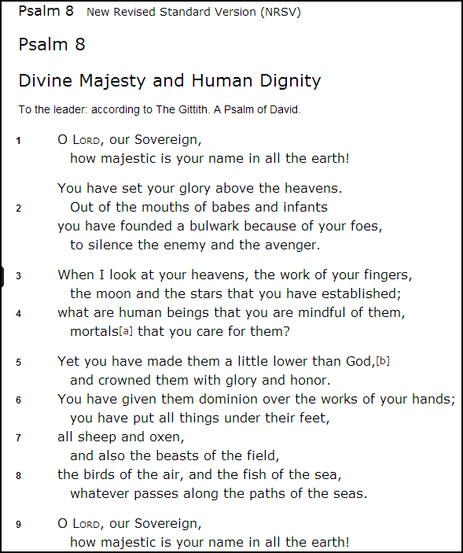

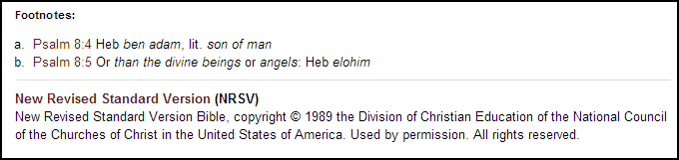

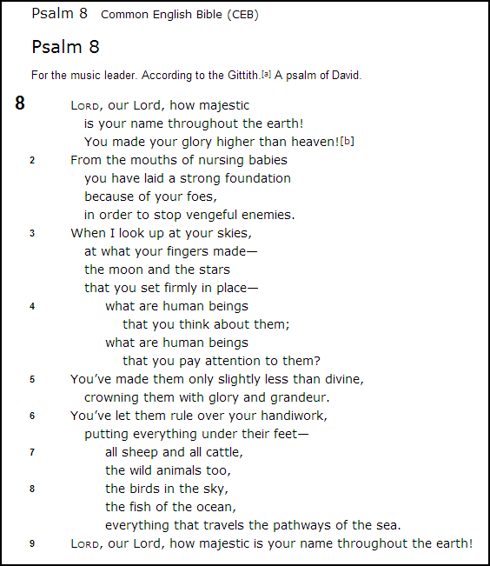

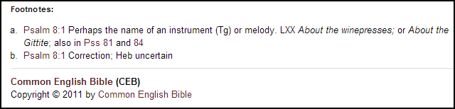

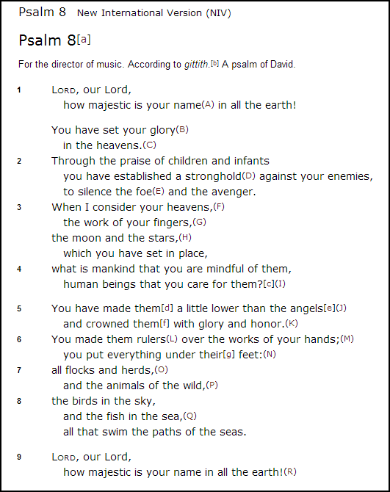
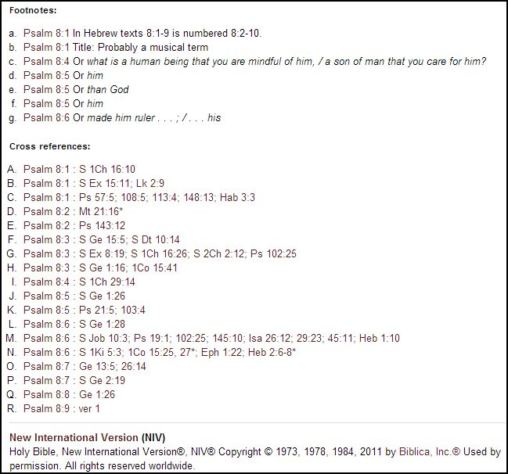
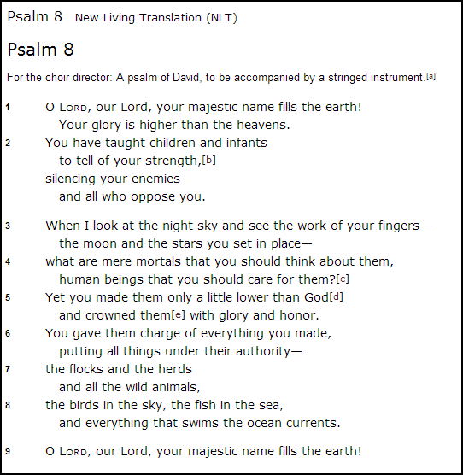

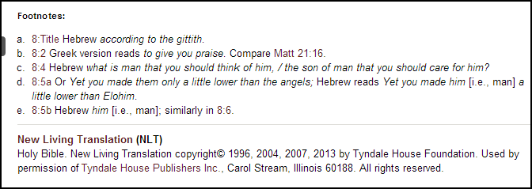

Handout Communication Triangle (Hayes and Holladay, 22-24)

1 Sender 2 Receiver

4 Signal

3 The World of Reality

1 Originator 2 Audience(s)

4 Biblical Text

3 Universe of Ideas and Events

Leader Cards (used to direct participants to resources which may answer questions during study of Ps 8)
- What does the pattern we notice tell us about Psalm 8? It is a praise psalm. The basic structure of praise psalms include: 1) address to God; 2) call to worship; 3) enumeration of reasons(s) to praise God; and 4) blessing(s) or a repetition of the initial call to worship. (Plummer, 250) Look for and list any patterns we see in Psalm 8.
  - NIB Commentary Vol IV: The proclamation of God’s reign frames the psalm (McCann, 711)
  - NIB One Vol Commentary: follows pattern 1) considers the magnitude 2) led to a question – why? 3) because God has a vocation for humanity (Gaventa and Petersen, 312); Descriptive praise to sing in worship – purpose is not to flatter God but to bear witness to God’s character, actions, and blessings. (Gaventa and Petersen, 308)
  - NIB Study Bible: Text divisions vv.1a,9 are the refrains – proclaims the majesty of the name in all the earth; vv.1b-8 are meditation on God’s glory and creation on descending spatial hierarchy that 1) begins above “the heavens” 2) moves to the “moon and the stars” and 3) focuses on humans and the earth creatures under humanity’s feet (or dominion); this human sovereignty is authorized by divine action and contextualized by praise of God’s name in the opening and closing. (Harrelson, et al., 758)
- What does Psalm 8 tell us about God?
  - NIB Commentary Vol IV: Word “name” connotes character and essence; extends God’s sovereignty beyond earth to the heavens; God does choose to be mindful (McCann, 711)
  - Harper Collins Study Bible: Psalms of praise usually have to do with character and power of God demonstrated in works of creation and acts of faithful love (Meeks, et al., 799)
  - Out of the Depths: in that culture gods were within nature, God transcends the cosmos, God not within the cosmos (Anderson, 154)
- What does Psalm 8 tell us about Humanity?
  - NIB Commentary Vol IV: affirm humanity’s royal status and dominion in context of God’s reign; primary actor is God – human subject of verb passive; v.4 questions lies at structural and thematic center – boundaries are God but humanity at the heart; id of humanity cannot be understood apart from relationship with God. (McCann, 711)
  - Out of the Depths: human dominion revolutionary in ancient religious culture; high calling to have dominion; are “image” to represent the rule of Kingdom of God on earth. (Anderson, 154)
  - NIB One Vol. Commentary: vocation; portrays as royalty to whom given responsibility (Gaventa and Petersen, 132)
  - NIB Study Bible: Dominion charge echoes Gen 1:26-28 in which humans rule over “all things” but not over one another; taking care of creation not exploiting it (Harrelson, et al., 759)
- Does Psalm 8 speak to the subject of the Image of God? Psalm 8 clearly recalls Genesis 1
  - NIB Commentary Vol IV: God rules, humanity has royal status too – “a little lower than God” elohim, “crown” “glory” “dominion” kingly functions; phrase “Image of God” does not occur but the language and movement of Psalm 8 suggest that humans represent God in the world; God and humans are partners in the care of creation because God has made the risky choice to share God’s power. (McCann, 711-712) The canonical placement of Psalm 8 after Psalms 3-7 suggests that to be created in the image of God means we will suffer too (McCann, 713)
  - Out of the Depths: they are “image” or represent the rule (kingdom) of God on earth (Anderson, 154)
  - NIB Study Bible: “little lower than God” or “heavenly beings” – LXX substitutes the word “angels”; point is…humanity’s place in creation is an extraordinary gift from God. Human beings, made by God, are like God, who crowned them with glory and honor. Thus humans are accorded royal status. (Harrelson, et al., 759)
- What does Psalm 8 tell us about humanity and the Image of God? Placement and Job (image of God = suffering as well as glory)
  - NIB Commentary Vol IV- Reflection 2: The canonical placement of Psalm 8 suggests the human creature who suffers miserably in Ps 3-7 and is then in Ps 8 v.5 “little lower than God” and “crowned with glory and honor”, suggests at least the royal status and vocation of humanity are not diminished by suffering, in fact we may conclude that to be created in “image of God” inevitably means we will suffer; also divine partnership with humanity inevitably involves God in suffering; Job rejects Ps 8 then moves to reclaim Ps 8 – learns royal status and vocation involves suffering as well as glory. (McCann, 712)
- How can babes silence enemies? Wording in verse 2 is a confusing juxtaposition.
  - NIV Commentary Vol IV: RSV and NIV translations treat v.2a as a continuation of v.1b inferring that even babies recognize God’s cosmic sovereignty; but NRSV v.2 implies that God can use even babies (vulnerable, helpless infants) as a power to oppose God’s foes; “foes”/”enemy”/”avenger” are probably chaotic forces that God conquered and ordered in the sovereign act of creation; v.2 anticipates vv.3-8 that God uses the weak and seemingly insignificant human creature as a partner in caring for creation that is constantly threatened by its enemy – chaos. (McCann, 711)
  - NIB Study Bible: It is unclear… 1) does the praise of children have the power to silence foes? Or 2) does v.2a continue v.1b so that even children recognize God’s majesty in all the earth? Or 3) does psalmist celebrate the power of human speech present even as speech begins? Mt 21:16 quotes this verse to claim that children have the truer perception of perfect praise. (Harrelson, et al., 759)
  - CEB Study Bible: Pairing military images and children is striking; God is so powerful that God can use babies as the first line of defense, that is, God turns weakness into strength (2Cor 12:9) – looks forward to v.3-8 in which small and helpless human beings are made “only slightly less than divine” (Ps 8:5) (Green, 847)
  - HarperCollins Study Bible: maybe praise comes even from babbling babes because this seems to be how it is used in Mt 21:16 (in which Ps 8 is quoted by Jesus in Matthew 21:16 in reference to children praising him in the temple); “founded a bulwark” may mean established strength. (Meeks, et al., 805)
- How is Psalm 8 used in the New Testament? Verses 4-6 are quoted in Heb 2:6-8 in reference to Jesus
  - NIB Commentary Vol IV – Reflection 2: quotes and applies to Jesus; author of Hebrews simply understood “son of man” in Ps 8:5 as a Christological title or Hebrews 2 as a whole points in the same direction as Ps 8 – 1) inseparability of suffering and glory for both God and humanity, 2) Jesus as “reflection of God’s glory” in (Heb 1:3) and complete embodiment of authentic humanity (Heb 2:14,17;4:15) who reveals Glory/Suffering; use of Ps 8 in Heb 2 faithful message of the original and NT as a whole call humans to 1) live under God’s rule and 2) exercise “dominion over all things” in the same way God exercises dominion: as a suffering servant. (McCann, 713)
  - NIB Study Bible: “mortals” poetic synonym of “human being” (Heb ‘enosh, v.4a) is literally ‘son of man”; Ezekiel is so addressed 80 times; in Dan 7:13-14, however, this phrase refers to a special human being figure who receives the heavenly gift of dominion; in the Gospels which are based in part on Daniel for the meaning of “son of man” writers refer coming heavenly judge, judge, savior, or to sayings about the suffering, death and resurrection of Jesus, or simply to Jesus himself. (Harrelson, et al., 759)

Handout: Leadership as Discernment (Seymour, Crain and Crockett, 177)

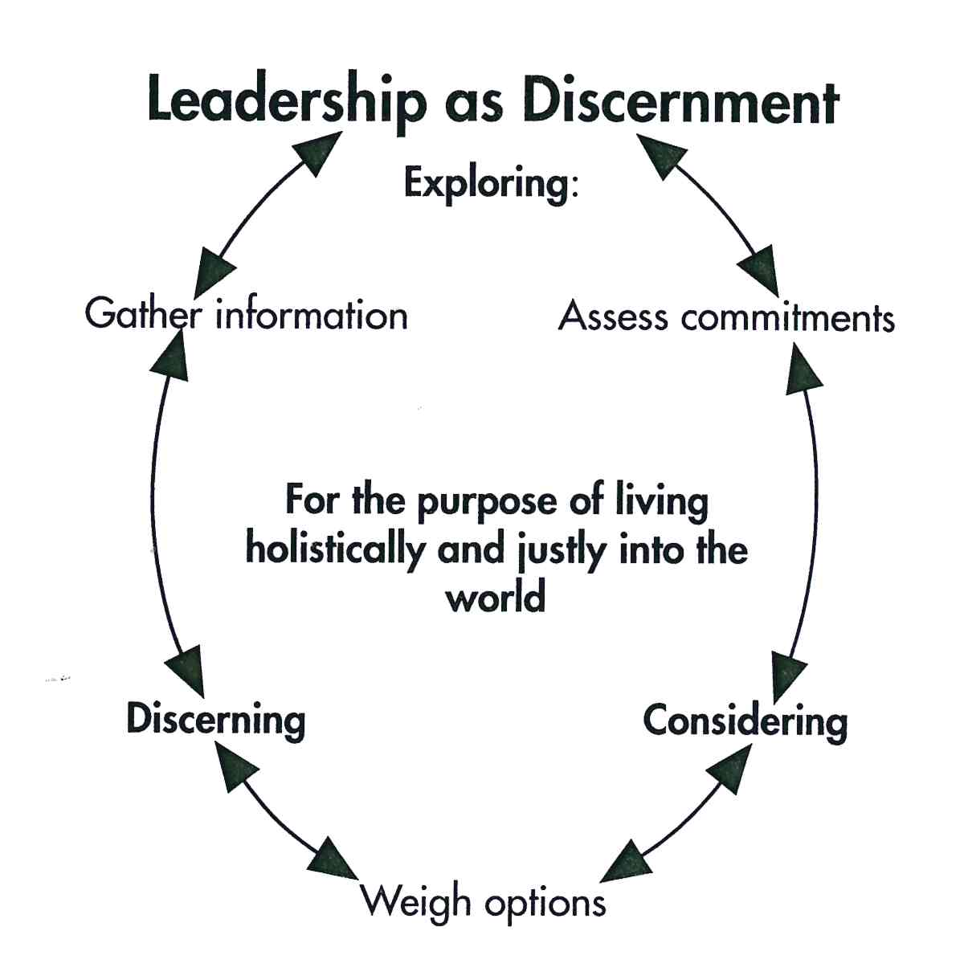

Basic Tenets of the Refomed Faith as described in The Book of Order (BO 2013)

F-2.01 THE PURPOSE OF CONFESSIONAL STATEMENTS
The Presbyterian Church (U.S.A.) states its faith and bears witness to God’s grace in Jesus Christ in the creeds and confessions in The Book of Confessions. In these statements the church declares to its members and to the world who and what it is, what it believes, and what it resolves to do. These statements identify the church as a community of people known by its convictions as well as by its actions. They guide the church in its study and interpretation of the Scriptures; they summarize the essence of Reformed Christian tradition; they direct the church in maintaining sound doctrines; they equip the church for its work of proclamation. They serve to strengthen personal commitment and the life and witness of the community of believers.

The creeds and confessions of this church arose in response to particular circumstances within the history of God’s people. They claim the truth of the Gospel at those points where their authors perceived that truth to be at risk. They are the result of prayer, thought, and experience within a living tradition. They appeal to the universal truth of the
Gospel while expressing that truth within the social and cultural assumptions of their time. They affirm a common faith tradition, while also from time to time standing in tension with each other.

F-2.02 THE CONFESSIONS AS SUBORDINATE STANDARDS
These confessional statements are subordinate standards in the church, subject to the authority of Jesus Christ, the Word of God, as the Scriptures bear witness to him. While confessional standards are subordinate to the Scriptures, they are, nonetheless, standards. They are not lightly drawn up or subscribed to, nor may they be ignored or dismissed. The church is prepared to instruct, counsel with, or even to discipline one ordained who seriously rejects the faith expressed in the confessions. Moreover, the process for changing the confessions of the church is deliberately demanding, requiring a high degree of consensus across the church. Yet the church, in obedience to Jesus Christ, is open to the reform of its standards of doctrine as well as of governance. The church affirms Ecclesia reformata, semper reformanda secundum verbum Dei, that is, “The church reformed, always to be reformed according to the Word of God” in the power of the Spirit.

F-2.03 THE CONFESSIONS AS STATEMENTS OF THE FAITH OF THE CHURCH CATHOLIC
In its confessions, the Presbyterian Church (U.S.A.) witnesses to the faith of the Church catholic. The confessions express the faith of the one, holy, catholic, and apostolic Church in the recognition of canonical Scriptures and the formulation and adoption of the ecumenical creeds, notably the Nicene and Apostles’ Creeds with their definitions of the mystery of the triune God and of the incarnation of the eternal Word of God in Jesus Christ.

F-2.04 THE CONFESSIONS AS STATEMENTS OF THE FAITH OF THE PROTESTANT REFORMATION
In its confessions, the Presbyterian Church (U.S.A.) upholds the affirmations of the Protestant Reformation. The focus of these affirmations is God’s grace in Jesus Christ as revealed in the Scriptures. The Protestant watchwords—grace alone, faith alone, Scripture alone—embody principles of understanding that continue to guide and motivate the people of God in the life of faith.

F-2.05 THE CONFESSIONS AS STATEMENTS OF THE FAITH OF THE REFORMED TRADITION
In its confessions, the Presbyterian Church (U.S.A.) expresses the faith of the Reformed tradition. Central to this tradition is the affirmation of the majesty, holiness, and providence of God who in Christ and by the power of the Spirit creates, sustains, rules, and redeems the world in the freedom of sovereign righteousness and love. Related to this central affirmation of God’s sovereignty are other great themes of the Reformed tradition:

The election of the people of God for service as well as for salvation;

Covenant life marked by a disciplined concern for order in the church according
to the Word of God;

A faithful stewardship that shuns ostentation and seeks proper use of the gifts of
God’s creation; and

The recognition of the human tendency to idolatry and tyranny, which calls the
people of God to work for the transformation of society by seeking justice and
living in obedience to the Word of God.

Evaluation Survey – Participant Reflection on the Project
Comments Concerning Preparation:
Did you feel you gained useful information and understanding of human and faith development prior to the immersion experience during the EXPLORE phase?
Not at all useful 1 2 3 4 5 Very useful
Did you feel that you gained a useful biblical perspective from the Psalm 8 bible study prior to the research experience in the CONSIDER phase?
Not at all useful 1 2 3 4 5 Very useful
Did you feel that the theological perspectives discussed were useful during the policy review and edit activity of the DISCERN phase?
Not at all useful 1 2 3 4 5 Very useful

Comments Concerning Engagement:
When sharing perspective or knowledge from your particular area of expertise how well do you feel your ideas were valued?
Not at all valued 1 2 3 4 5 Very valued
When working together on group activities how well do you feel your opinions were respected?
Not at all respected 1 2 3 4 5 Very respected
How well organized do you feel the following experiences were:
Immersion experiences during the EXPLORE phase?
Not at all organized 1 2 3 4 5 Very well organized
Research experiences during the CONSIDER phase?
Not at all organized 1 2 3 4 5 Very well organized
Review and edit experiences during the DISCERN phase?
Not at all organized 1 2 3 4 5 Very well organized

Comments Concerning Reflection:
How well do you feel the group was able to articulate the list of concerns/issues, which was our main objective of the EXPLORE phase?
Not at all well articulated 1 2 3 4 5 Very well articulated
How well do you feel the group was able to articulate the statement of value and intent which was our main objective of the CONSIDER phase?
Not at all well articulated 1 2 3 4 5 Very well articulated
How well do you feel the group was able to plan for teacher training and informing the congregation on the requirements of the new policy, which was the main objective of the DISCERN phase?
Not at all well articulated 1 2 3 4 5 Very well articulated

Section C – Evaluation of the Design as Implemented
Discovering the biblical and theological underpinnings of our project was, I hoped, a foundation upon which the group could craft a policy that would motivate and inspire those who must abide by and support it. During the implementation of the design I did notice some real value in the preparation components of the design. While it was tempting to proceed directly to engagement experiences which seemed to be the main and expected activities for a project like this, preparation was useful in giving participants tools and insights required in order to make the most of the engagement experiences. Participant feedback showed an average rating of 3.75 out of 5 on the scale of how useful the information on human and faith development was prior to the immersion experience during the explore phase. One participant reflected, “I think this process substantially changed the nature of our conversations and priorities in the revision of the policy from legal and insurance concerns to caring for each child of God.” Feedback showed an average rating of 4.25 when asked how useful the biblical perspective gained from the Psalm 8 bible study prior to the research experience in the consider phase. One participant told me, “The Bible study was my favorite part of this project. I wish we could have spent more time on this part of the project.” Participant feedback showed an average 4.0 rating of how useful the discussion of theological perspectives was to prepare for the policy review and editing activity during the discern phase. One participant remarked, “I really wasn’t sure what to expect with this exercise, but found everything that we [discussed] gave me more perspective in how to pull faith and Jesus into what seemed to be a very administrative project.” The administrative activities were, I believe, made more meaningful for having prepared for them in these ways.
Overall the teaching strategies employed were heavily student research oriented with group development of end-products that were required for the next phases of the project. The engagement experiences were central to the main objectives of the project. During the explore phase, we examined our current policy and saw for ourselves how that policy was being enacted in classes and programs at the various age-levels. One participant said, “I found my immersion experience to be very enriching and informative. I gained a new appreciation for what goes into children’s worship.” All participants reported that they felt the immersion experience was very well organized. During the consider phase we did our research - examining insurance requirements and looking at other policies to use as benchmark comparisons. The most enlightening part of this research work was interviewing a survivor of child abuse. Listening to a firsthand account of how devastating it was to that person’s life and ability to function, and being able to ask questions about what, as a faith community, we can do to prevent such abuse was invaluable. Participants, after learning how long it takes, how much counseling is involved, and how much work it is to recover from abuse, were motivated to include in the statement of value and intent their commitment to affirming and supporting those who are affected by the horrors of child abuse. This particular part of the research served to motivate the team to design a good policy and commit to enforcing it so that would not happen to another person. Participant feedback returned a high rating, an average of 4.5 on a scale of 5, for the research activities in all three phases of the project being very well organized. During the discern phase the engagement was actually updating the policy using research from the consider phase and the understanding of our existing policy gleaned from the explore phase. This phase in particular utilized group process and required respect for each member’s experience and area of expertise. Feedback showed that participant’s valued each other’s experience and input to a high degree. When asked to rate how well they felt their ideas were valued when they were sharing perspective or knowledge from their particular area of expertise the response was an average of 4.75 out of 5. All participants reported that they felt their opinions were respected when working on cooperative tasks by returning a perfect 5.0 in the participant reflection on the event. One participant remarked, “This is a great group of thinkers…sharing ideas is easy and welcomed in this group, [with] very well organized discussion[s].”
The educational design contained three phases - explore, consider, and discern - each with the three components - prepare, engage, and reflect. Each interlocking piece was designed to motivate and inspire the members of the CE Committee along the path toward achieving the end goal of creating a new policy. As this project took place over the summer with many meetings and activities taking place when our committee did not normally meet, it presented challenges for timing and full attendance. The reflection components were some of the most difficult to time properly. It was important to allow time between the engagement experience and the reflection component in order to allow time to ponder the issues and generate the ideas required to complete the output task of each phase. We always broke for at least several days before doing the reflection and that was very valuable. The reflection for the explore phase had as its output a list of issues to address in the next phase of the project, and participant feedback shows that most felt that it was well articulated, with an average rating of 4.25 out of 5. The reflection for the consider phase generated a statement of value and intent, and most felt that it was well articulated, with an average rating of 4.75 out of 5. The reflection for the discern phase generated a plan for teacher training, and rated a little lower, with an average of 4.25 out of 5, because, as one participant commented, “I think we need to be better prepared for how we are going to implement the strategy. I know some ideas have been discussed, but I think we need to have a concrete strategy for implementation.” This last component coming at the end of a long project was a more challenging one to complete.
Each session objective and the educational approaches selected to achieve them were appropriate and effective. If the process were to be repeated, I would present the sessions closer together and, in some cases, in more of a retreat format, in order to accomplish the activities in a more concentrated, shorter timeframe. I would, however, still want to provide time and space between each engagement experience and its corresponding reflection component. One participant reflected, “Sometimes I was not always clear on the objectives for each phase, so reiterating them would be helpful.” Perhaps having too much time between components required more reiteration of the way the pieces and the objectives of each piece fed into the next than was done in the implementation. Based on these insights, I would change the design of the immersion experience to occur on the same day instead of sending the participants off to select a time and venue that meets their criteria and availability. In that way the explore phase could be accomplished in a shorter amount of time. I would implement the design of the research experiences during the consider phase to provide speakers and presentation of material within one large block of time such as an all morning or afternoon retreat. Similarly I would implement the engagement component of the discern phase, the one in which the policy is actually edited, as a retreat-like session that would include the preparation component for that phase and the editing activities in a large block of time. I would, however, keep each of the reflection components as stand-alone activities that occur several days after each preparation and engagement “retreat” session. This implementation adjustment, though, would require a clear explanation of how the reflection objective ties back to the preparation and engagement experience for that phase, and how the end-product of the reflection feeds into the next phase.
The overall goal of creating a policy that guides our congregation to live out our call as a community of faith to protect children from abuse was achieved and my expectations for the project were exceeded. In addition to the high quality of skills and experiences of the participants, the preparation components added an element of learning that enhanced the project. Because of a thorough examination of the biblical and theological foundations the group could better articulate our call. Because of the personal experiences and wide range of research done during the engagement components, the group felt confident in starting fresh in crafting the policy rather than merely updating our existing policy. For example, this fresh perspective led to inclusion of children with special needs as a population that required extra supervision and consideration for the volunteers that work with them. Because of the careful attention paid to accomplishing the objective for each phase during the reflection components, the participants were encouraged to craft ways in which we could actually enact God’s love in this place and in these circumstances and make a positive change for the sake of children in our faith community.

Bibliography
Anderson, Bernhard W. Out of the Depths: The Psalms Speak for Us Today. Philadelphia, PA: The Westminster Press, 1983.

Baker, Matt. Useful Charts for Lesson Plans, Study Help and Quick Reference. January 8, 2013. http://www.usefulcharts.com/psychology/james-fowler-stages-of-faith.html (accessed April 24, 2014).
—. Useful Charts for Lesson Plans, Study Help or Quick Reference. January 8, 2013. http://www.usefulcharts.com/psychology/erikson-stages-of-development-chart.html (accessed April 24, 2014).

BO. The Book of Order 2013-2015. Louisville: The Office of the General Assembly Presbyterian Church (U.S.A.), 2013.

BOC. The Book of Confessions. Louisville: The Office of the General Assembly Presbyterian Church (U.S.A.), 2002.

Gaventa, Beverly Roberts, and David, eds. Petersen. The New Interpreter's Bible One Volume Commentary. Nashville: Abingdon Press, 2010.

Green, Joel B, ed. The CEB Study Bible. Nashville: Common English Bible, 2013.

Guthrie, Shirley J Jr. "Suffering, Liberation, and the Sovereignty of God." In Always Being Reformed: Faith for a Fragmented World 2nd ed., by Shirley J Jr Guthrie, 41-55. Louisville: Westminster John Knox Press, 2008.

Harrelson, Walter J, Donald Senior, Abraham Smith, Phyllis Trible, and James C, eds. VanderKam. The New Interpreter's Study Bible New Revised Standard Version with the Apocrypha. Nashville: Abington Press, 2003.

Hayes, John H, and Carl R Holladay. Biblical Exegesis: A Beginner's Handbook Third Edition. Louisville, Kentucky: Westminster John Knox Press, 2007.

McCann, J Clinton Jr. "Psalms." In The New Interpreter's Bible Commentary in Twelve Volumes: Volume IV, by Leander E Keck, et al., 639-1280. Nashville: Abingdon Press, 1996.

McKim, Donald K. Introducing the Reformed Faith: Biblical Revelation, Christian Tradition, Contemporary Significance. Louisville: Westminster John Knox Press, 2001.

Meeks, Wayne A, Jouette N Bassler, Werner E Lemke, Susan Niditch, and Eileen M, eds. Schuller. The HarperCollins Study Bible New Revised Standard Version with the Apocryphal/Deuterocanonical Books 1st Pbk. Ed. HarperSanFrancisco, 1997.

Migliore. Faith Seeking Understanding: An Introduction to Christian Theology, second edition. Grand Rapids: Eerdmans, 2004.

Plummer, Robert L. 40 Questions About Interpreting the Bible. Grand Rapids, MI: Kregel Publications, 2010.

Seymour, Jack L, Margaret Ann Crain, and Joseph V Crockett. Educating Christians: The Intersection of Meaning, Learning, and Vocation. Nashville: Abington Press, 1993.
Stroup, George W. "God's Freedom from and for the World." In Always Being Reformed: Faith for a Fragmented World 2nd ed., by Shirley C Jr. Guthrie, 121-139. Louisville: Westminster John Knox Press, 2008.

R.C. Sproul, Keith A. Mathison. Reformation Study Bible - ESV. Ligonier Ministries, 2010.

